Redhill Primary Academy

**Child-on Child Abuse Policy**

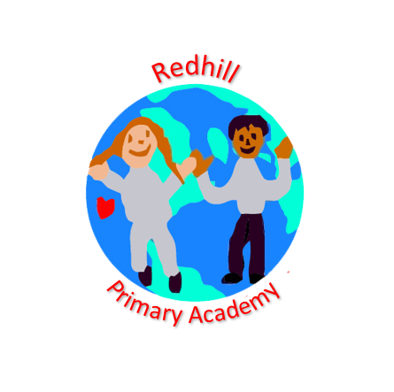

**Signed**

**Mrs Fiona Seddon, Chair of Governors**

|  |  |  |
| --- | --- | --- |
| **Approved by:** |  | **Date: 09.20** |
| **Last reviewed on:** | **June 2022** | |
| **Next review due by:** | **July 2023** | |

**Introduction**

Redhill Primary Academy recognises that children are vulnerable to and capable of abusing their peers. We take such abuse as seriously as abuse perpetrated by an adult. This includes verbal as well as physical abuse. Child-on-child abuse will not be tolerated or passed off as part of “banter”, “just having a laugh” or “growing up”.

The governors, senior leadership team, and all staff (which term shall apply to all volunteer staff members) at Redhill Primary Academy. The Academy is committed to the prevention, early identification, and appropriate management of child-on-child abuse (as defined below) both within and beyond the School.

In cases where child-on-child abuse is identified, we will follow our child protection procedures, taking a contextual approach to support all children and young people who have been affected by the situation.

We recognise that child-on-child abuse is most likely to include, but may not be limited to:

* bullying (including cyberbullying);
* physical abuse such as hitting, kicking, shaking, biting, hair pulling, or otherwise causing physical harm;
* sexual violence, such as rape, assault by penetration and sexual assault;
* sexual harassment, such as sexual comments, remarks, jokes and online sexual harassment, which may be stand-alone or part of a broader pattern of abuse;
* upskirting, which typically involves taking a picture under a person’s clothing without them knowing, with the intention of viewing their genitals or buttocks to obtain sexual gratification, or cause the victim humiliation, distress or alarm;
* sexting (also known as youth produced sexual imagery), and
* initiation/hazing type violence and rituals.

Some of these behaviours will need to be handled with reference to other policies in school such as the behaviour policy, anti- bullying policy, child protection policy and online safety policy.

This policy is compliant with the statutory guidance on child-on-child abuse as set out in Keeping Children Safe in Education (September 2020).

**Policy development**

This policy:

* is the Academy’s overarching policy for any issue that could constitute child-on-child abuse. It relates to, and should be read alongside, the Academy’s child protection policy and any other relevant policies including, but not limited to, online safety, IT use, data protection and retention of records, children missing in education, child behaviour and discipline, exclusions, and (where relevant) weapons;
* sets out our strategy for improving prevention, and identifying and appropriately managing child-on-child abuse;
* it is reviewed annually, and updated in the interim, as may be required, to ensure that it continually addresses the risks to which children are or may be exposed.
* recognises that abuse is abuse, and should never be passed off as ‘banter’, ‘just having a laugh’, or ‘part of growing up’;
* does not use the term ‘victim’ and/or ‘perpetrator’. This is because our Academy takes a safeguarding approach to all individuals involved in concerns or allegations about child-on-child abuse, including those who are alleged to have been abused, and those who are alleged to have abused their peers, in addition to any sanctioning work that may also be required for the latter. Research has shown that many children who present with harmful behaviour towards others, in the context of child-on-child abuse, are themselves vulnerable and may have been victimised by peers, parents or adults in the community prior to their abuse of peers;
* uses the terms ‘child’ and ‘children’, which is defined for the purposes of this policy as a person aged under 18. Although the starting point is that the Academy’s response to child-on-child abuse should be the same for all children, regardless of age, there may be some different considerations in relation to, for example, a child aged under 7, or a child aged 11;
* similarly, the Academy’s response to incidents involving the exchange of youth involved sexual imagery will need to differ depending on the age of the children involved;
* should, if relevant, according to the concern(s) or allegation(s) raised, be read in conjunction with the DfE’s advice on Sexual Violence and Sexual Harassment Between Children in Schools and Colleges (DfE’s Advice) (May 2018), and any other advice and guidance referred to within it, as appropriate; and
* should be read in conjunction with the Telford and Wrekin Partnership Safeguarding Policy and Procedures.

**Understanding child-on-child abuse**

Child-on-child abuse is any form of physical, sexual, emotional and financial abuse, and coercive control, exercised between children, and within children’s relationships (both intimate and non-intimate), friendships and wider peer associations.

Child-on-child abuse can take various forms, including (but not limited to): serious bullying (including cyberbullying), relationship abuse, domestic violence and abuse, child sexual exploitation, youth and serious youth violence, harmful sexual behaviour, and/or prejudice-based violence including, but not limited to, gender-based violence.

Examples of online child-on-child abuse would include sexting, online abuse, child-on-child grooming, the distribution of youth involved sexualised content, and harassment.

Sexual violence and sexual harassment can occur between two children of any age and sex or a group of children sexually assaulting or sexually harassing a single child or group of children. The impact of this behaviour on children can be very distressing and have an impact on academic achievement and emotional health and wellbeing. Sexual harassment and sexual violence may also occur online and offline.

Holistic account of child-on –chil abuse (taken from [https://www.farrer.co.uk/globalassets/clients-and-sectors/safeguarding/farrer--co-safeguarding-child-on-child-abuse-toolkit-2019.pdf](https://www.farrer.co.uk/globalassets/clients-and-sectors/safeguarding/farrer--co-safeguarding-peer-on-peer-abuse-toolkit-2019.pdf))

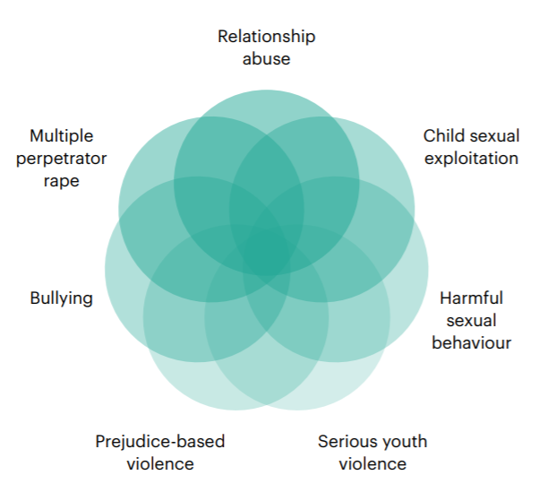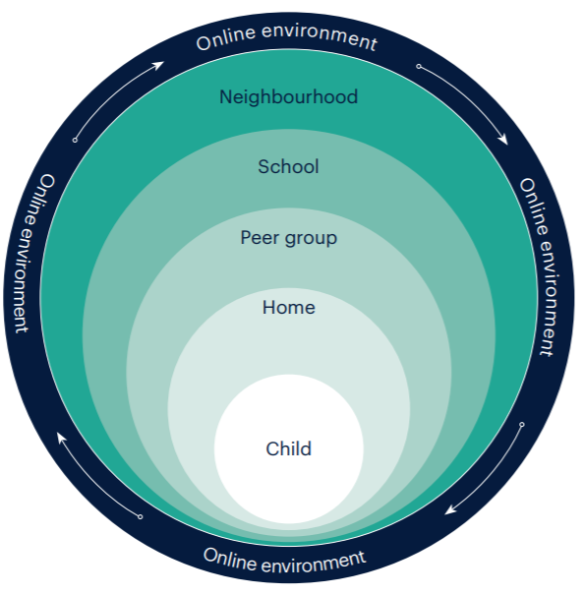

Contextual circles of adolescent vulnerability (taken from [https://www.farrer.co.uk/globalassets/clients-and-sectors/safeguarding/farrer--co-safeguarding-child-on-child-abuse-toolkit-2019.pdf](https://www.farrer.co.uk/globalassets/clients-and-sectors/safeguarding/farrer--co-safeguarding-peer-on-peer-abuse-toolkit-2019.pdf))

**The context**

This policy:

* encapsulates a Contextual Safeguarding approach, which is about changing the way that professionals approach child protection when risks occur outside of the family, thereby requiring all those within the Local Safeguarding Partnership to consider how they work alongside, rather than just refer into, children’s social care, to create safe spaces in which children may have encountered child-on-child abuse;
* adopts a whole-school community Contextual Safeguarding approach, which means:
* being aware of and seeking to understand the impact that these wider social contexts may be having on the Academy’s children;
* creating a safe culture in the Academy by, for example, implementing policies and procedures that address child-on-child abuse and harmful attitudes;
* promoting healthy relationships and attitudes to gender/ sexuality;
* hotspot mapping to identify risky areas in the Academy;
* training on potential bias and stereotyped assumptions,
* being alert to and monitoring changes in a child’s behaviour and/or attendance; and
* contributing to local child protection agendas by, for example, challenging poor threshold decisions and referring concerns about contexts to relevant local agencies.

All behaviour takes place on a spectrum. Understanding where a child's behaviour falls on a spectrum is essential to being able to respond appropriately to it. In this policy, we recognise the importance of distinguishing between problematic and abusive **sexual behaviour** (Harmful Sexual Behaviour HSB).

We are adopting the NSPCC definition of HSB as: -

"Sexual behaviours expressed by children…that are developmentally inappropriate, may be harmful towards self or others, or be abusive towards another child…or adult."

We will also use Simon Hackett‘s continuum model to demonstrate the range of sexual behaviours (Appendix 1) and the Brook Traffic Lights (Appendix 2). Hackett’s continuum relates exclusively to sexual behaviours and is not exhaustive. The Brook Sexual Behaviours Traffic Light Tool can help professionals working with children to distinguish between three levels of sexual behaviour – green, amber and red, and to respond according to the level of concern.

**Other behaviour**

When dealing with other alleged behaviour, which involves reports of, for example, emotional and/or physical abuse, staff can draw on aspects of Hackett’s continuum to assess where the alleged behaviour falls on a spectrum and to decide how to respond. This could include, for example, whether it:

* is socially acceptable,
* involves a single incident or has occurred over a period of time,
* is socially acceptable within the peer group,
* is problematic and concerning,
* involves any overt elements of victimisation or discrimination e.g. related to race, gender, sexual orientation, physical, emotional, or intellectual vulnerability,
* involves an element of coercion or pre-planning,
* involves a power imbalance between the child/children allegedly responsible for the behaviour and the child/children allegedly the subject of that power, and
* involves a misuse of power.

**How can a child who is being abused by their peers be identified?**

All staff should be alert to the well-being of children and to signs of abuse, and should engage with these signs, as appropriate, to determine whether they are caused by child-on-child abuse. However, staff should be mindful of the fact that the way(s) in which children will disclose or present with behaviour(s) as a result of their experiences will differ.

The Academy’s safeguarding team should regularly review behaviour incident logs, which can help to identify any changes in behaviour and/or concerning patterns or trends at an early stage.

**Are some children particularly vulnerable to abusing or being abused by their peers?**

Any child can be vulnerable to child-on-child abuse due to the strength of peer influence during adolescence, and staff should be alert to signs of such abuse amongst all children. Individual and situational factors can increase a child’s vulnerability to abuse by their peers. Peer group dynamics can also play an important role in determining a child’s vulnerability to such abuse. Children who are questioning or exploring their sexuality may also be particularly vulnerable to abuse by their peers.

Research suggests that:

* Child-on-child abuse may affect boys differently from girls, and that this difference may result from societal norms (particularly around power, control and the way in which femininity and masculinity are constructed) rather than biological make-up.
* Barriers to disclosure will also be different. As a result, schools need to explore the gender dynamics of child-on-child abuse within their settings and recognise that these will play out differently in single sex, mixed or gender- imbalanced environments.
* Children with Special Educational Needs and/or Disabilities (SEND) are three times more likely to be abused than their peers without SEND,60 and additional barriers can sometimes exist when recognising abuse in children with SEND. These can include:
* assumptions that indicators of possible abuse such as behaviour, mood and injury relate to a child’s disability without further exploration;
* the potential for children with SEND to be disproportionately impacted by behaviours such as bullying and harassment, without outwardly showing any signs;
* communication barriers and difficulties, and overcoming these barriers;
* some children may be more likely to experience child-on-child abuse than others as a result of certain characteristics such as sexual orientation, ethnicity, race or religious beliefs.

**Responding to alleged incidents responding to reports of sexual violence and sexual harassment**

**General principles**

It is essential that all concerns and allegations of child-on-child abuse are handled sensitively, appropriately and promptly. The way in which they are responded to can have a significant impact on our school environment.

Following an incident of harmful sexual behaviour, there are a number of actions that

the Academy should take to decide whether a safety plan is needed, and to develop

a plan that is robust and effective. If a safety plan is needed, the Academy will refer to the Centre of Expertise on Child Sexual Abuse’s *‘Safety planning in education: A guide for professionals supporting children following incidents of harmful sexual behaviour’*. (Appendix 3)

Any response should:

* include a thorough investigation of the concern(s) or allegation(s), and the wider context in which it/they may have occurred (as appropriate) – depending on

the nature and seriousness of the alleged incident(s), it may be appropriate for the police and/or children’s social care to carry out this investigation;

* treat all children involved as being at potential risk – while the child allegedly responsible for the abuse may pose a significant risk of harm to other children;
* she/he may also have considerable unmet needs and be at risk of harm themselves. The Academy should ensure that a safeguarding response is in place for both the child who has allegedly experienced the abuse, and the child who has allegedly been responsible for it, and additional sanctioning work may be required for the latter,
* take into account:
* that the abuse may indicate wider safeguarding concerns for any of the children involved, and consider and address the effect of wider sociocultural contexts – such as the child’s/ children’s peer group (both within and outside the Academy); the family; the school environment; their experience(s) of crime and victimisation in the local community; and the child/children’s online presence. Consider what changes may need to be made to these contexts to address the child/children’s needs and to mitigate risk; and
* the potential complexity of child-on-child abuse and of children´s experiences, and consider the interplay between power, choice and consent. While children may appear to be making choices, if those choices are limited, they are not consenting;
* the views of the child/children affected. Unless it is considered unsafe to do so (for example, where a referral needs to be made immediately), the DSL should discuss the proposed action with the child/children and their parents, and obtain consent to any referral before it is made. The Academy should manage the child/children’s expectations about information sharing, and keep them and their parents informed of developments, where appropriate and safe to do so. It is particularly important to take into account the wishes of any child who has allegedly been abused, and to give that child as much control as is reasonably possible over decisions regarding how any investigation will be progressed and how they will be supported.

**What should you do if you suspect either that a child may be at risk of or experiencing abuse by their peer(s), or that a child may be at risk of abusing or may be abusing their peer(s)?**

The member of staff should discuss their concern with the DSL without delay (in accordance with pages 6-9 of the child protection policy) so that a course of action can be agreed. The DSL will discuss the concern(s) or allegation(s) with the member of staff who has reported it/them and will, where necessary, take any immediate steps to ensure the safety of the child/all children affected.

If a child speaks to a member of staff about child-on-child abuse that they have witnessed or are a part of, the member of staff should listen to the child and use open language that demonstrates understanding rather than judgement. For further details please see the procedures set out in pages 6-9 of the child protection policy.

In relation to sexting, also known as youth produced sexual imagery, the Academy will where necessary, consult with guidance produced by The UK Council for Child Internet Safety (UKCCIS) Education Group Sexting in Schools and Colleges and DfE guidance Searching, screening and confiscation. The DSL (or deputy) will take the lead on these issues.

Where any concern(s) or allegation(s) indicate(s) that indecent images of a child or children may have been shared online, the DSL should consider what urgent action can be taken in addition to the actions and referral duties set out in this policy to seek specialist help in preventing the images spreading further and removing the images from the internet.

The Internet Watch Foundation (IWF), for example, has a trained team that can evaluate and remove illegal images from the internet when the images are reported

to them quickly. They will also share the image with the National Crime Agency’s CEOP Command to facilitate an investigation. Any report to IWF will be made in consultation with the police.

DSLs should always use their professional judgement to consider:

* the nature and seriousness of the alleged behaviour.
* whether it is appropriate for the alleged behaviour to be to be dealt with internally and, if so, whether any external specialist support is required. In borderline cases the DSL may wish to consult with Family Connect on a no-names basis (where possible) to determine the most appropriate response.
* the wishes of the victim in terms of how they want to proceed. This is especially important in the context of sexual violence and sexual harassment.
* the ages and developmental stages of the children involved.
* any power imbalance between the children. For example, is the alleged perpetrator significantly older, more mature or more confident? Does the victim have a disability or learning difficulty?
* if the alleged incident is a one-off or a sustained pattern of abuse.
* are there ongoing risks to the victim, other children, adult or the Academy staff, and other related issues and wider context?

**Options to manage the abuse**

1. Manage internally. In some cases, for example, one-off incidents, we may decide that the children concerned are not in need of early help or statutory intervention and that it would be appropriate to handle the incident internally, perhaps through utilising the behaviour and bullying policies and by providing pastoral support. This decision will be made based on the principle that child-on-child abuse is never acceptable and will not be tolerated. All decisions, and discussions around making these decisions will be recorded and stored (by the Designated Safeguarding Lead and placed on CPOMS).

2. In line with 1 above, we may decide that the children involved do not require statutory interventions but may benefit from early help. Early help means providing support as soon as a problem emerges, at any point in a child’s life. Providing early help is more effective in promoting the welfare of children than reacting later. Early help can be particularly useful to address nonviolent harmful sexual behaviour and may prevent escalation of sexual violence. These services may, for example, include family and parenting programmes, responses to emerging thematic concerns in extra familial contexts, a specialist harmful sexual behaviour team, CAMHS and/or youth offending services.

3. Where a child has been harmed, is at risk of harm, or is in immediate danger, we will make a referral to Family Connect following locally agreed protocols. Where statutory assessments are appropriate, the designated safeguarding lead or a deputy will be working alongside, and cooperating with, the relevant lead social worker. Collaborative working will help ensure the best possible package of coordinated support is implemented for the victim and, where appropriate, the alleged perpetrator and any other children that require support. As a matter of best practice, if an incident of child-on-child abuse requires referral to and action by children’s social care and a strategy meeting is convened, then the Academy will hold every professional involved in the case accountable for their safeguarding response, including themselves, to both the/each child who has experienced the abuse, and the/each child who was responsible for it, and the contexts to which the abuse was associated.

4. Report alleged criminal behaviour to the police. Alleged criminal behaviour will ordinarily be reported to the police. However, there are some circumstances where it may not be appropriate to report such behaviour to the police. For example, where the exchange of youth involved sexual imagery does not involve any aggravating factors. All concerns or allegations will be assessed on a case by case basis.

**Risk Assessment**

When there has been a report of sexual violence, the designated safeguarding lead (or a deputy) will make an immediate risk and needs’ assessment (see Appendix 6). Where there has been a report of sexual harassment, the need for a risk assessment should be considered on a case-by-case basis.

Risk assessments will be recorded (written or electronic and uploaded onto CPOMS) and be kept under review. It may be appropriate to contact children’s social care and/or police to assist in carrying out a safety plan. The DSL may use and consider the [TWSP Sexually harmful behaviour - risk assessment tool](http://www.telfordsafeguardingboard.org.uk/lscb/downloads/file/38/sexually_harmful_behaviour_-_risk_assessment_tool).

**Actions to consider during the investigation and post investigation**

Whilst the Academy establishes the facts of the case and starts, where applicable, the process of liaising with children’s social care and the police, the perpetrator may be removed from any classes they share with the victim. We will consider how best to keep the victim and alleged perpetrator a reasonable distance apart on Academy premises. These actions are in the best interests of both children and should not be perceived to be a judgment on the guilt of the alleged perpetrator.

**Reporting to the Police**

Any report to the police will generally be made through Family Connect as above. The designated safeguarding lead (and their deputies) will follow local processes for referrals.

Where a report of rape, assault by penetration or sexual assault is made, the starting point is this will be passed on to the police. Whilst the age of criminal responsibility is ten, if the alleged perpetrator is under ten, the starting principle of reporting to the police remains. The police will take a welfare, rather than a criminal justice, approach.

Where a report has been made to the police, the Academy will consult the police and agree what information can be disclosed to staff and others, the alleged perpetrator and their parents or carers. They will also discuss the best way to protect the victim and their anonymity.

Where there is a criminal investigation, we will work closely with the relevant agencies to support all children involved (especially potential witnesses). Where required, advice from the police will be sought in order to help us. Whilst protecting children and/or taking any disciplinary measures against the alleged perpetrator, we will work closely with the police (and other agencies as required), to ensure any actions the Academy takes do not jeopardise the police investigation.

**The end of the criminal process**

If a child is convicted or receives a caution for a sexual offence, the Academy will update its risk assessment, ensure relevant protections are in place for all children. We will consider any suitable action following our behaviour policy. If the perpetrator remains in the Academy we will be very clear as to our expectations regarding the perpetrator now they have been convicted or cautioned. This could include expectations regarding their behaviour and any restrictions we think are reasonable and proportionate about the perpetrator’s timetable. Any conviction (even with legal anonymity reporting restrictions) is potentially going to generate interest among other children in the Academy. We will ensure all children involved are protected, especially from any bullying or harassment (including online).

Where cases are classified as “no further action” (NFA’d) by the police or Crown Prosecution Service, or where there is a not guilty verdict, we will continue to offer support to the victim and the alleged perpetrator for as long as is necessary. A not guilty verdict or a decision not to progress with their case will likely be traumatic for the victim. The fact that an allegation cannot be substantiated does not necessarily mean that it was unfounded. We will continue to support all parties in this instance.

**Support for children affected by sexual-assault**

Support for victims of sexual assault is available from a variety of agencies (see Appendix 4). We will support the victim of sexual assault to remain in Academy but if they are unable to do so we will enable them to continue their education elsewhere.

This decision will be made only at the request of the child and their family. If they are moved, we will ensure the new Academy is aware of the ongoing support they may need. The DSL will support this move.

Where there is a criminal investigation the alleged perpetrator will be removed from any shared classes with the victim and we will keep them a reasonable distance apart on the Academy premises. This is in the best interest of the children concerned and should not be perceived to be a judgement of guilt before any legal proceedings.

Where a criminal investigation into a rape or assault by penetration leads to a conviction or caution, we may take suitable action, if we have not already done so. In all but the most exceptional of circumstances, the rape or assault is likely to constitute a serious breach of discipline and lead to the view that allowing the perpetrator to remain in the same Academy would seriously harm the education or welfare of the victim (and potentially other children). Where a criminal investigation into sexual assault leads to a conviction or caution, we may, if we have not already done so, consider any suitable sanctions using our behaviour policy, including consideration of permanent exclusion.

Where the perpetrator is going to remain at the Academy, the principle would be to continue keeping the victim and perpetrator in separate classes and continue to consider the most appropriate way to manage potential contact on Academy premises and transport. The nature of the conviction or caution and wishes of the victim will be especially important in determining how to proceed in such cases.

Reports of sexual assault and sexual harassment will, in some cases, not lead to a report to the police (for a variety of reasons). In some cases, rape, assault by penetration, sexual assault or sexual harassment are reported to the police and the case is not progressed or are reported to the police and ultimately result in a not guilty verdict. None of this means the offence did not happen or that the victim lied. The process will have affected both victim and alleged perpetrator. Appropriate support will be provided to both as required and consideration given to sharing classes and potential contact as required on a case-by-case basis.

All the above will be considered with the needs and wishes of the victim at the heart of the process (supported by parents as required).

**Physical abuse**

While a clear focus of child-on-child abuse is around sexual abuse and harassment, physical assaults and initiation violence and rituals from peer to peer can also be abusive. These are equally not tolerated and if it is believed that a crime has been committed, will be reported to the police. The principles from the bullying policy will be applied in these cases, with recognition that any police investigation will need to take priority.

When dealing with other alleged behaviour which involves reports of, for example, emotional and/or physical abuse, staff can draw on aspects of Hackett’s continuum (Appendix 1) to assess where the alleged behaviour falls on a spectrum and to decide how to respond. This could include, for example, whether it:

* is socially acceptable
* involves a single incident or has occurred over a period of time
* is problematic and concerning
* involves any overt elements of victimisation or discrimination e.g. related to race, gender, sexual orientation, physical, emotional, or intellectual vulnerability
* involves an element of coercion or pre-planning
* involves a power imbalance between the child/children allegedly responsible for the behaviour or a misuse of power

**Online behaviour**

Many forms of child-on-child abuse have an element of online behaviour including behaviours such as cyberbullying and sexting. Policies and procedures concerning this type of behaviour can be found in our behaviour policy, online safety policy, and child protection policy.

**Prevention**

Our Academy, actively seeks to raise awareness of and prevent all forms of child-on-child abuse by:

* Educating all Governors, staff and volunteers, and parents about this issue. This will include training all Governors, Senior Leadership Team, staff and volunteers on the nature, prevalence and effect of child-on-child abuse, and how to prevent, identify and respond to it. This includes:
* Contextual Safeguarding;
* The identification and classification of specific behaviours; and
* The importance of taking seriously all forms of child-on-child abuse (no matter how low level they may appear) and ensuring that no form of child-on-child abuse is ever dismissed as horseplay or teasing.
* Educating children about the nature and prevalence of child-on-child abuse via PSHE and the wider curriculum.
* Children are frequently told what to do if they witness or experience such abuse, the effect that it can have on those who experience it and the possible reasons for it, including vulnerability of those who inflict such abuse.
* They are regularly informed about the Academy’s approach to such issues, including its zero tolerance policy towards all forms of child-on-child abuse.
* Engaging parents on this issue by:
* Talking about it with parents, both in groups and one to one;
* Asking parents what they perceive to be the risks facing their child and how they would like to see the Academy address those risks;
* Involving parents in the review of Academy policies and lesson plans; and
* Encouraging parents to hold the Academy to account on this issue.
* Ensuring that all child-on-child abuse issues are fed back to the Academy’s designated safeguarding lead so that they can spot and address any concerning trends and identify children who maybe in need of additional support. This is done by way of a weekly staff meeting at which all concerns about children (including child-on-child abuse issues) are discussed.
* Challenging the attitudes that underlie such abuse (both inside and outside the classroom).
* Working with Governors, TTMAT, Senior Leadership Team, all staff and volunteers, children and parents to address equality issues, to promote positive values, and to encourage a culture of tolerance and respect amongst all members of the Academy community.
* Creating conditions in which our children can aspire to and realise safe and healthy relationships.
* Creating a culture in which our children feel able to share their concerns openly, in a non-judgmental environment, and have them listened to.
* Responding to cases of child-on-child abuse promptly and appropriately.

**Appendix 1**

Simon Hackett (2010) has proposed a continuum model to demonstrate the range of sexual behaviours presented by children and young people, from those that are normal, to those that are highly deviant:

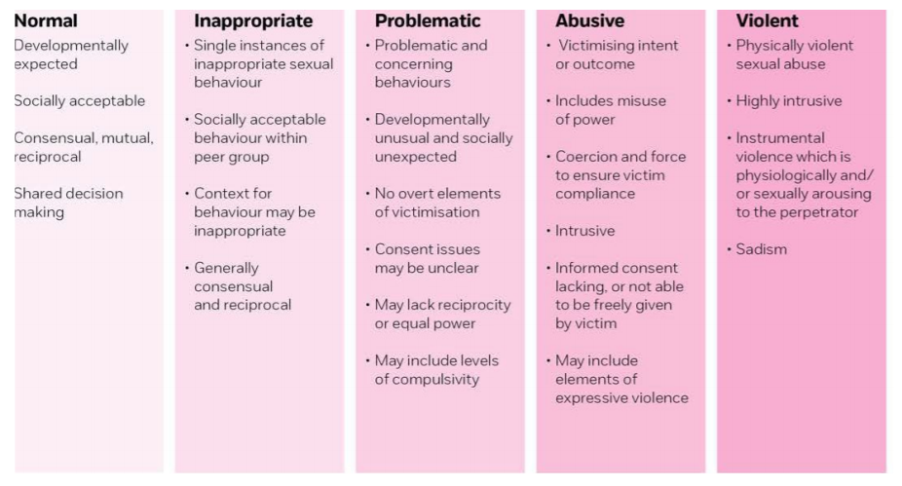

The continuum recognises that there are times when children’s sexual behaviour is a cause for concern. Hackett calls this ‘harmful sexual behaviour’, defining it as:

*Sexual behaviours expressed by children and young people under the age of 18-years-old, that are developmentally inappropriate, may be harmful towards self or others, or be abusive towards another child, young person or adult.*

<https://learning.nspcc.org.uk/research-resources/2016/harmful-sexual-behaviour-framework>

**Appendix 2**

Brook sexual behaviours traffic light tool

IDENTIFY

**What is the behaviour?**

Sexual development is influenced by many factors.

The environment in which children grow, develop and interact has a significant influence on their knowledge, attitudes and behaviours. When using Traffic Lights® to establish whether children or young people’s sexual behaviour is typical and developmentally appropriate, problematic or harmful, it is necessary to consider the current social, cultural and family context.

Use Traffic Lights® to identify the characteristics of the behaviour and the way it occurs and then follow steps 2 and 3 to understand and respond. All green, orange and red light behaviours require some level of information, support and protective response.

UNDERSTAND

**What is the behaviour communicating?**

All behaviour communicates. Once you have identified a behaviour, it is important to explore and understand the context before responding.

Children and young people show their needs and wants through their behaviours. Understanding the reasons for a child or young person’s sexual behaviour is important so adults can support healthy sexual development and provide appropriate information and support.

When sexual behaviours are typical and developmentally appropriate they are usually part of natural curiosity and making sense of the world.

However, when sexual behaviours are identified as problematic or harmful, it is essential to think about why the child or young person may be exhibiting the behaviour. The child or young person may not have the language, experience or ability to seek help.

**What might the behaviour indicate?**

Examples include:

* Curiosity
* It feels good
* Learning about privacy
* Learning about touch and social rules
* Exploring sexual identity and gender roles
* Experiencing feelings of sexual attraction
* Lack of age and developmentally appropriate sexuality information
* Possible grooming, child sexual exploitation
* Exposure to explicit sexual activity including online content
* Experience of physical, emotional or sexual abuse or neglect

RESPOND

**What response will meet the child or young person’s needs?**

All behaviour has a function. When adults understand why the behaviour may be happening, they can respond by helping to meet the needs of the child or young person in effective ways.

Behaviour usually reflects a range of needs and all sexual behaviours require a response, even those identified as developmentally appropriate (green light behaviours).

The type of response will depend on what is motivating the behaviour, what the behaviour might be communicating and the severity of the behaviour.

When children or young people’s sexual behaviour is problematic or harmful a range of strategies may be needed to respond effectively.

**AGE GROUP 0-4 YEARS**

GREEN LIGHT BEHAVIOURS ARE SEXUAL BEHAVIOURS THAT ARE TYPICAL AND DEVELOPMENTALLY APPROPRIATE. EXPRESSING SEXUALITY THROUGH SEXUAL BEHAVIOUR IS NATURAL, HEALTHY AND A PART OF GROWING UP.

**Green light behaviours are:**

* Spontaneous, curious, light hearted, easily diverted, enjoyable, mutual and consensual
* Appropriate to the child’s age and/or stage of development
* Activities or play among equals in terms of age, size and ability levels
* About understanding and gathering information, balanced with curiosity about other parts of life

Green light behaviours provide opportunities to **talk**, **explain** and **provide support**.

**Example green light behaviours for a developmental age of 0-4 years include:**

* Comfortable being nude
* Body touching and holding own genitals
* Unselfconscious masturbation
* Interest in body parts and functions
* Wanting to touch familiar children’s genitals during play, toilet or bath times
* Participation in games involving looking at and/or touching the bodies of familiar children e.g. “show me yours and I’ll show you mine”
* Asking about or wanting to touch the breasts, bottoms or genitals of familiar adults e.g. when in the bath or shower
* Supervised online communication with family or known peers

WHAT CAN YOU DO?

**Green light behaviours provide an opportunity to positively reinforce appropriate behaviour, and to provide further information, explanations, and support.**

All children and young people have the right to relationships and sex education which equips them with the information and skills they need to form healthy and positive relationships and to help keep them safe. We can support the child/young person’s natural curiosity by talking and providing explanations about healthy sexual behaviours that are age and stage appropriate to their learning.

If you are a professional working with young people and your organisation has internal guidance or safeguarding frameworks, please refer to these to decide on the next steps to take. Your policy or procedure should guide you towards a designated safeguarding lead who can be notified and will provide support.

**I am not a professional working with young people. Where can I go for help?**

If you are not a professional working within an organisation with internal procedures or frameworks, you may want to consider contacting a specialist organisation that can advise you. These include:

* **Police services:** Call 999 if the child is at immediate risk, or call the police on 101 if you think a crime has been committed
* [**NSPCC:**](http://www.nspcc.org.uk/) 0808 800 5000
* [**Childline:**](https://www.childline.org.uk/) 0800 1111
* [**Child Exploitation and Online Protection Centre (CEOP):**](http://www.ceop.police.uk/)0870 000 3344
* [**ForwardUK:**](https://www.forwarduk.org.uk/violence-against-women-and-girls/female-genital-mutilation/) More information and support on FGM
* [**Brook:**](http://www.brook.org.uk/)Young people's sexual health services

ORANGE LIGHT BEHAVIOURS ARE SEXUAL BEHAVIOURS WHICH CAUSE CONCERN.

**Orange light behaviours cause concern because of:**

* The persistence, intensity, frequency or duration of the behaviours
* The type of activity or knowledge for the age and/or stage of development
* Inequality in age, size, power or developmental ability
* Risk to the health and safety of the child or others
* Unusual changes in a child’s behaviour

Orange light behaviours signal the need to **monitor** and **provide targeted support**.

**They cannot be ignored** and it is important to think through the options available for the child/young person.

EXAMPLES OF ORANGE LIGHT BEHAVIOURS

**Example orange light behaviours for a developmental age of 0-4 years include:**

* Masturbation in preference to other activities
* Preoccupation with sexual behaviours
* Explicit sexual talk, art or play
* Persistently watching or following others into private spaces e.g. toilets, bathrooms to look at them or touch them
* Pulling other children’s pants down or skirts up against their will
* Touching the genitals/private parts of other children in preference to other activities
* Attempting to touch or touching adults on the breasts, bottom, or genitals in ways that are persistent and/or invasive
* Touching the genitals/private parts of animals after redirection
* Recurrent urinary tract infections
* Communicating online with known people which may include giving out personally identifying details

WHAT CAN YOU DO?

**Orange light behaviours signal the need to pay attention, monitor and gather information to consider appropriate action.**

This is a good opportunity to provide sexuality and personal safety education to all of those involved. This may also be an opportunity to help support the child or young person to understand the risks to themselves or to those around them.

The child/young person may also require some form of 1:1 intervention, counselling, and/or protections from harm. It’s important to talk to the child/young person about their options for support and involve parents/carers, if appropriate, or another known adult who is able to support the child.

Recognising that behaviour may be unhealthy is the first step in a process. Dealing with unhealthy sexual behaviour at an early stage can help to prevent subsequent sexually harmful behaviours from developing, which will help to keep the child/young person and those around them safe.

If you are a professional working with young people and your organisation has internal guidance or safeguarding frameworks, please refer to these to decide on the next steps to take. Your policy or procedure should guide you towards a designated safeguarding lead who can be notified and will provide support.

RED LIGHT BEHAVIOURS ARE SEXUAL BEHAVIOURS WHICH INDICATE OR CAUSE HARM.

**Red light behaviours indicate or cause harm because they are:**

* Excessive, compulsive, coercive, forceful, degrading or threatening
* Secretive, manipulative or involve bribery or trickery
* Not appropriate for the age and/or stage of development
* Between children with a significant difference in age, developmental ability or power
* Abusive or aggressive

Red light behaviours signal the need to provide **immediate protection** and **follow up support**.

EXAMPLES OF RED LIGHT BEHAVIOURS

**Example red light behaviours for a developmental age of 0-4 years include:**

* Compulsive masturbation which may be self-injurious, of a persistent nature or duration
* Persistent explicit sexual themes in talk, art or play
* Disclosure of sexual abuse
* Simulation of sexual touch or sexual activity
* Persistently touching the genitals/ private parts of others
* Forcing other children to engage in sexual activity
* Sexual behaviour between young children involving penetration with objects, masturbation of others, oral sex
* Indication of a sexually transmitted infection
* Communicating online with known and unknown people which may include giving out personally identifying details and / or sexual images or videos

WHAT CAN YOU DO?

**Red light behaviours signal the need to provide immediate protection and follow up support, and it is important to consider actions carefully.**

Following an immediate response there will also be a need to monitor, and provide sexuality and personal safety education to the child/young person and any others involved. It’s important to talk to the child/young person about their options for further support, this could include some form of 1:1 intervention and/or counselling, and involve parents/carers, if appropriate, or another known adult who is able to support the child.

When determining the appropriate action, identify the behaviour, consider the context and be guided by:

* Relevant national legislation and guidance; are protections from harm and/or a legal response required?
* Organisational policies, procedures and guidance
* Human rights
* The identified risks or needs of the child/young person
* The potential or real risks to others, for example are there any other children involved?

If you are a professional working with young people and your organisation has internal guidance or safeguarding frameworks, please refer to these to decide on the next steps to take. Your policy or procedure should guide you towards a designated safeguarding lead who can be notified and will provide support.

**Report harm or abuse.** If you are aware of, or reasonably suspect, a child has been or is being sexually abused, is at risk of sexual abuse or is at risk of sexually abusing others, you should contact child protection services or the police.

**AGE 5-7 YEARS**

REMEMBER: IDENTIFY, UNDERSTAND, RESPOND

GREEN LIGHT BEHAVIOURS ARE SEXUAL BEHAVIOURS THAT ARE TYPICAL AND DEVELOPMENTALLY APPROPRIATE. EXPRESSING SEXUALITY THROUGH SEXUAL BEHAVIOUR IS NATURAL, HEALTHY AND A PART OF GROWING UP.

**Green light behaviours are:**

* Spontaneous, curious, light hearted, easily diverted, enjoyable, mutual and consensual
* Appropriate to the child’s age and/or stage of development
* Activities or play among equals in terms of age, size and ability levels
* About understanding and gathering information, balanced with curiosity about other parts of life

Green light behaviours provide opportunities to **talk**, **explain** and **provide support**.

EXAMPLES OF GREEN LIGHT BEHAVIOURS

**Example green light behaviours for a developmental age of 5-7 years include:**

* Increased sense of privacy about bodies
* Body touching and holding own genitals
* Masturbation with increasing awareness of privacy
* Curiosity about other children’s genitals involving looking at and/or touching the bodies of familiar children e.g. “show me yours and I’ll show you mine”
* Curiosity about sexuality e.g., questions about babies, gender, relationships, sexual activity
* Telling stories or asking questions, using swear words, ‘toilet’ words or names for private parts
* Kissing or holding hands with known peers
* Mimicking or acting out observed behaviours such as pinching a bottom
* Supervised online communication with family or known peers

WHAT CAN YOU DO?

**Green light behaviours provide an opportunity to positively reinforce appropriate behaviour, and to provide further information, explanations, and support.**

All children and young people have the right to relationships and sex education which equips them with the information and skills they need to form healthy and positive relationships and to help keep them safe. We can support the child/young person’s natural curiosity by talking and providing explanations about healthy sexual behaviours that are age and stage appropriate to their learning.

If you are a professional working with young people and your organisation has internal guidance or safeguarding frameworks, please refer to these to decide on the next steps to take. Your policy or procedure should guide you towards a designated safeguarding lead who can be notified and will provide support.

ORANGE LIGHT BEHAVIOURS ARE SEXUAL BEHAVIOURS WHICH CAUSE CONCERN.

**Orange light behaviours cause concern because of:**

* The persistence, intensity, frequency or duration of the behaviours
* The type of activity or knowledge for the age and/or stage of development
* Inequality in age, size, power or developmental ability
* Risk to the health and safety of the child or others
* Unusual changes in a child’s behaviour

Orange light behaviours signal the need to **monitor** and **provide targeted support**.

**They cannot be ignored** and it is important to think through the options available for the child/young person.

**Example orange light behaviours for a developmental age of 5-7 years include:**

* Persistent rubbing / touching own genitals after redirection
* Masturbation in preference to other activities in public; with others and/or causing self-injury
* Explicit talk, art or play of sexual nature
* Playing / attempting to play “show me yours and I’ll show you mine” games with significantly older or younger children
* Persistent attempts to touch the genitals of other children
* Persistent interest in touching or viewing other people’s private body parts / private activities
* Persistent questions about sexuality despite being answered
* Persistent nudity and/or exposing private parts in public places
* Touching genitals/private parts of animals after redirection
* Recurrent urinary tract infections
* Communicating online with known people which may include giving out personally identifying details

WHAT CAN YOU DO?

**Orange light behaviours signal the need to pay attention, monitor and gather information to consider appropriate action.**

This is a good opportunity to provide sexuality and personal safety education to all of those involved. This may also be an opportunity to help support the child or young person to understand the risks to themselves or to those around them.

The child/young person may also require some form of 1:1 intervention, counselling, and/or protections from harm. It’s important to talk to the child/young person about their options for support and involve parents/carers, if appropriate, or another known adult who is able to support the child.

Recognising that behaviour may be unhealthy is the first step in a process. Dealing with unhealthy sexual behaviour at an early stage can help to prevent subsequent sexually harmful behaviours from developing, which will help to keep the child/young person and those around them safe.

If you are a professional working with young people and your organisation has internal guidance or safeguarding frameworks, please refer to these to decide on the next steps to take. Your policy or procedure should guide you towards a designated safeguarding lead who can be notified and will provide support.

RED LIGHT BEHAVIOURS ARE SEXUAL BEHAVIOURS WHICH INDICATE OR CAUSE HARM.

**Red light behaviours indicate or cause harm because they are:**

* Excessive, compulsive, coercive, forceful, degrading or threatening
* Secretive, manipulative or involve bribery or trickery
* Not appropriate for the age and/or stage of development
* Between children with a significant difference in age, developmental ability or power
* Abusive or aggressive

Red light behaviours signal the need to provide **immediate protection** and **follow up support**.

**Example red light behaviours for a developmental age of 5-7 years include:**

* Rubbing / touching own genitals to the exclusion of usual activities
* Masturbation that is compulsive, self-injurious, or seeking an audience
* Rubbing own genitals on other people
* Disclosure of sexual abuse
* Simulation of sexual touch or sexual activity
* Forcing other children to play sexual games
* Sexual knowledge beyond expected for age or stage of development
* Indication of a sexually transmitted infection
* Excessive talk about sex and sexual activity
* Communicating online with known and unknown people which may include giving out personally identifying details and / or sexual images or videos

WHAT CAN YOU DO?

**Red light behaviours signal the need to provide immediate protection and follow up support, and it is important to consider actions carefully.**

Following an immediate response there will also be a need to monitor, and provide sexuality and personal safety education to the child/young person and any others involved. It’s important to talk to the child/young person about their options for further support, this could include some form of 1:1 intervention and/or counselling, and involve parents/carers, if appropriate, or another known adult who is able to support the child.

When determining the appropriate action, identify the behaviour, consider the context and be guided by:

* Relevant national legislation and guidance; are protections from harm and/or a legal response required?
* Organisational policies, procedures and guidance
* Human rights
* The identified risks or needs of the child/young person
* The potential or real risks to others, for example are there any other children involved?

If you are a professional working with young people and your organisation has internal guidance or safeguarding frameworks, please refer to these to decide on the next steps to take. Your policy or procedure should guide you towards a designated safeguarding lead who can be notified and will provide support.

**Report harm or abuse.** If you are aware of, or reasonably suspect, a child has been or is being sexually abused, is at risk of sexual abuse or is at risk of sexually abusing others, you should contact child protection services or the police.

**AGE 8-12 YEARS OLD**

REMEMBER: IDENTIFY, UNDERSTAND, RESPOND

GREEN LIGHT BEHAVIOURS ARE SEXUAL BEHAVIOURS THAT ARE TYPICAL AND DEVELOPMENTALLY APPROPRIATE. EXPRESSING SEXUALITY THROUGH SEXUAL BEHAVIOUR IS NATURAL, HEALTHY AND A PART OF GROWING UP.

**Green light behaviours are:**

* Spontaneous, curious, light hearted, easily diverted, enjoyable, mutual and consensual
* Appropriate to the child’s age and/or stage of development
* Activities or play among equals in terms of age, size and ability levels
* About understanding and gathering information, balanced with curiosity about other parts of life

Green light behaviours provide opportunities to **talk**, **explain** and **provide support**.

**Example green light behaviours for a developmental age of 8-12 years include:**

* Growing need for privacy
* Masturbation, with increasing awareness of privacy
* Curiosity about other children’s genitals involving looking at and/ or touching the bodies of familiar children e.g. “show me yours and I’ll show you mine” games with peers
* Showing curiosity about private parts but having a respect for the privacy of others
* Hugging, kissing, flirting, touching with known peers
* Interest and/or participation in a relationship with a peer of any gender
* Curiosity and seeking information about sexuality
* Use of sexual language
* Exhibitionism amongst same age peers within the context of play e.g. occasional flashing or mooning
* Communicating online with family and known peers

WHAT CAN YOU DO?

**Green light behaviours provide an opportunity to positively reinforce appropriate behaviour, and to provide further information, explanations, and support.**

All children and young people have the right to relationships and sex education which equips them with the information and skills they need to form healthy and positive relationships and to help keep them safe. We can support the child/young person’s natural curiosity by talking and providing explanations about healthy sexual behaviours that are age and stage appropriate to their learning.

If you are a professional working with young people and your organisation has internal guidance or safeguarding frameworks, please refer to these to decide on the next steps to take. Your policy or procedure should guide you towards a designated safeguarding lead who can be notified and will provide support.

ORANGE LIGHT BEHAVIOURS ARE SEXUAL BEHAVIOURS WHICH CAUSE CONCERN.

**Orange light behaviours cause concern because of:**

* The persistence, intensity, frequency or duration of the behaviours
* The type of activity or knowledge for the age and/or stage of development
* Inequality in age, size, power or developmental ability
* Risk to the health and safety of the child or others
* Unusual changes in a child’s behaviour

Orange light behaviours signal the need to **monitor** and **provide targeted support**.

**They cannot be ignored** and it is important to think through the options available for the child/young person.

**Example orange light behaviours for a developmental age of 8-12 years include:**

* Masturbation in preference to other activities, in public and/ or causing self-injury
* Persistent explicit talk, art or play which is sexual or sexually intimidating
* Intentional viewing of other people’s private body parts / private activities
* Marked changes to behaviour e.g. mimicking older or adult flirting behaviours, seeking relationships with older children or adults in preference to peers
* Simulation of sexual activities e.g. oral sex, sexual intercourse with clothes on
* Mutual /self-masturbation with known and unknown peers
* Hugging, kissing, flirting, touching with unknown peers
* Accessing age restricted materials e.g. movies, games, internet with sexually explicit content
* Persistent expression of fear of sexually transmitted infection or pregnancy
* Recurrent urinary tract infections
* Communicating online with known people which may include giving out personally identifying details

WHAT CAN YOU DO?

**Orange light behaviours signal the need to pay attention, monitor and gather information to consider appropriate action.**

This is a good opportunity to provide sexuality and personal safety education to all of those involved. This may also be an opportunity to help support the child or young person to understand the risks to themselves or to those around them.

The child/young person may also require some form of 1:1 intervention, counselling, and/or protections from harm. It’s important to talk to the child/young person about their options for support and involve parents/carers, if appropriate, or another known adult who is able to support the child.

Recognising that behaviour may be unhealthy is the first step in a process. Dealing with unhealthy sexual behaviour at an early stage can help to prevent subsequent sexually harmful behaviours from developing, which will help to keep the child/young person and those around them safe.

If you are a professional working with young people and your organisation has internal guidance or safeguarding frameworks, please refer to these to decide on the next steps to take. Your policy or procedure should guide you towards a designated safeguarding lead who can be notified and will provide support.

**Red light behaviours indicate or cause harm because they are:**

* Excessive, compulsive, coercive, forceful, degrading or threatening
* Secretive, manipulative or involve bribery or trickery
* Not appropriate for the age and/or stage of development
* Between children with a significant difference in age, developmental ability or power
* Abusive or aggressive

Red light behaviours signal the need to provide **immediate protection** and **follow up support**.

**Example red light behaviours for a developmental age of 8-12 years include:**

* Compulsive masturbation e.g. self-injurious, seeking an audience
* Persistent bullying involving sexual aggression e.g. pulling/ lifting/removing other children’s clothing, sexually threatening notes, sending sexually explicit material, drawings, text messages
* Degrading or humiliating self or others using sexual themes
* Disclosure of sexual abuse
* Accessing the rooms of sleeping children to touch or engage in sexual activity
* Touching another person’s genitals without permission
* Sexual activity or penetration of animals
* Sexual penetration of dolls and/or stuffed toys
* Participating in or simulating intercourse and/or oral sex with known or unknown peers with clothes off
* Sexual activity in exchange for material items or privileges
* Indication of sexually transmitted infection or pregnancy
* Communicating online with unknown people which may include giving out personally identifying details
* Communicating online with known and unknown people to send or publish sexual images, videos or audio of self or another person

WHAT CAN YOU DO?

**Red light behaviours signal the need to provide immediate protection and follow up support, and it is important to consider actions carefully.**

Following an immediate response there will also be a need to monitor, and provide sexuality and personal safety education to the child/young person and any others involved. It’s important to talk to the child/young person about their options for further support, this could include some form of 1:1 intervention and/or counselling, and involve parents/carers, if appropriate, or another known adult who is able to support the child.

When determining the appropriate action, identify the behaviour, consider the context and be guided by:

* Relevant national legislation and guidance; are protections from harm and/or a legal response required?
* Organisational policies, procedures and guidance
* Human rights
* The identified risks or needs of the child/young person
* The potential or real risks to others, for example are there any other children involved?

If you are a professional working with young people and your organisation has internal guidance or safeguarding frameworks, please refer to these to decide on the next steps to take. Your policy or procedure should guide you towards a designated safeguarding lead who can be notified and will provide support.

**Report harm or abuse.** If you are aware of, or reasonably suspect, a child has been or is being sexually abused, is at risk of sexual abuse or is at risk of sexually abusing others, you should contact child protection services or the police.

**Appendix 3**

Safety planning in education: A guide for professionals supporting children following incidents of

harmful sexual behaviour.

A copy of the full document is available for reference in the Academy’s safeguarding folders.

Safety planning: a summary

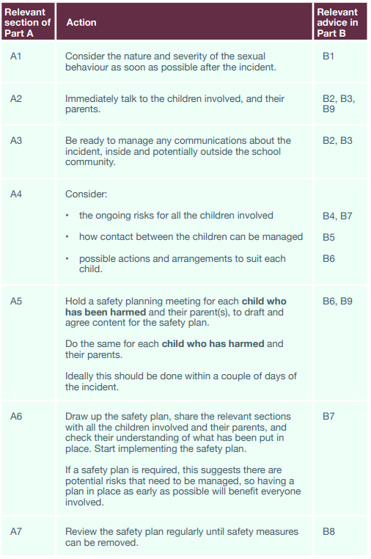

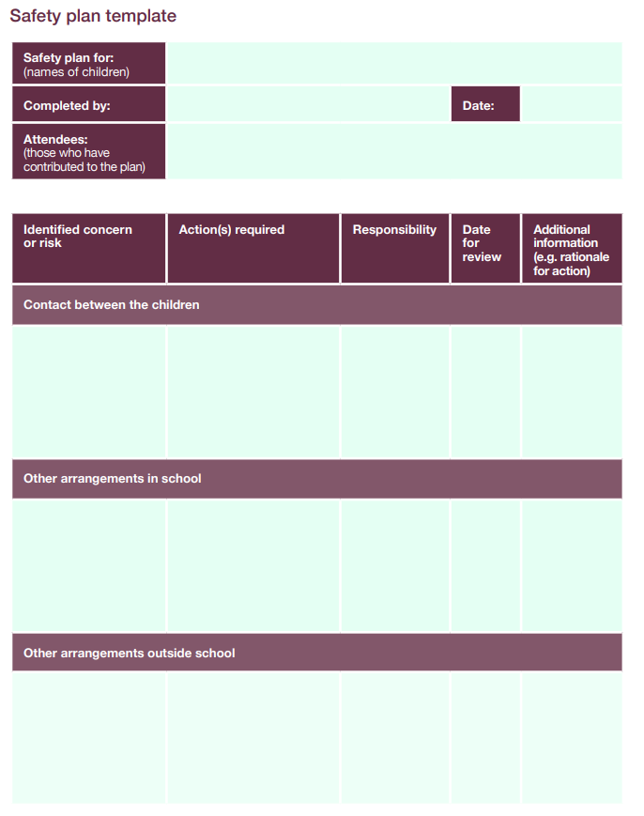

**Appendix 4**

Support for Young People: Local and National

A dedicated NSPCC helpline 0800 136 663 went live from Thursday 1st April 2021 in response to the government announcing an immediate enquiry into allegations of sexual abuse in schools. This helpline is to support potential victims of sexual harassment and abuse. Run by the NSPCC it aims to provide advice and support to both children and adults who are victims of abuse in school. It will also include how to contact the police to report crimes. The advice line is also available to support professionals and parents.

Child and adolescent mental health services (CAMHS)

<https://camhs.mpft.nhs.uk/beeu>

Internet Watch Foundation (to potentially remove illegal images)

[www.iwf.org.uk](http://www.iwf.org.uk)

The National Clinical Assessment and Treatment Service (NCATS)

<https://www.nspcc.org.uk/services-and-resources/childrens-services/ncats/>

Offers assessment and treatment services to children and young people with harmful sexual behaviour, and consultation and training to professionals managing complex or high-risk harmful sexual behaviour cases

The Lucy Faithful Foundation (LFF)

<https://www.stopitnow.org.uk/>

Stop It Now! UK and Ireland is a child abuse prevention campaign and helpline which is run by the LFF –supporting adults to play their part in prevention through providing sound information, educating members of the public, training those who work with children and families, and running a confidential and anonymous helpline (available for anyone with concerns about child sexual abuse)

What’s the problem? A guide for parents of children and young people who have got in trouble online

<https://www.parentsprotect.co.uk/>

Parents Protect provides services to agencies working with children and their families – for those with problematic sexual behaviour on the internet and in the ‘real world’. Parents Protect is a project of the LFF, and provides an online resource for parents, and others who want to protect children from harm.

Red Balloon Learning Centres

<http://www.redballoonlearner.org/>

Red Balloon supports children who self-exclude from school and are missing education because of bullying or other trauma. It provides an academic and therapeutic programme to enable its childs to get back on track and reconnect with society.

Leap Confronting Conflict

<http://www.leapconfrontingconflict.org.uk/>

Leap is an award-winning national youth charity that provides inspirational conflict management programmes and support to children (and young adults) and the professionals working with them.

Barnardo’s

<https://www.barnardos.org.uk/what_we_do/our_work/sexual_exploitation/cseprofessionals/cse-can-you-seeit.htm>

**Appendix 5**

Government Guidance

HM Government, What to do if you’re worried a child is being abused, advice for practitioners, March 2015

<https://assets.publishing.service.gov.uk/government/uploads/system/uploads/attachment_data/file/419604/What_to_do_if_you_re_worried_a_child_is_being_abused.pdf>

Department for Education, Preventing and Tackling Bullying: Advice for headteachers, staff and governing bodies, July 2017

<https://www.gov.uk/government/uploads/system/uploads/attachment_data/file/623895/Preventing_and_tackling_bullying_advice.pdf>

Department for Education, Sexual Violence and Sexual Harassment Between Children in Schools and Colleges: Advice for Governing Bodies, Proprietors, Head Teachers, Principals, Senior Leadership Teams and Designated Safeguarding Leads, May 2018

<https://assets.publishing.service.gov.uk/government/uploads/system/uploads/attachment_data/file/719902/Sexual_violence_and_sexual_harassment_between_children_in_schools_and_colleges.pdf>

Department for Education, Working Together to Safeguard Children: A guide to inter-agency working to safeguard and promote the welfare of children, July 2018

<https://assets.publishing.service.gov.uk/government/uploads/system/uploads/attachment_data/file/729914/Working_Together_to_Safeguard_Children-2018.pdf>

Examples of further resources

Department for Education, Keeping Children Safe in Education: Statutory guidance for schools and colleges, September 2020

<https://assets.publishing.service.gov.uk/government/uploads/system/uploads/attachment_data/file/892394/Keeping_children_safe_in_education_2020.pdf>

General

Contextual Safeguarding Practitioners’ Network

[www.contextualsafeguarding.org.uk](http://www.contextualsafeguarding.org.uk)

**Appendix 6 Risk Assessment**

| area of risk | | considerations | | Child ‘a’ | Child ‘b’ | notes | actions |
| --- | --- | --- | --- | --- | --- | --- | --- |
| Details of the incident  Record details of the incident from the point of view of both children | | * How serious is the incident? Was it a crime? * Do we need to make arrangements to limit contact between the children involved? (If the allegation relates to rape, assault by penetration, or sexual assault, the answer is automatically yes) * How did the school find out about it? Was it reported directly or by someone else with knowledge of the incident? | |  |  | Use this column to record additional information that may be relevant  For example, previous, unrelated behaviour incidents |  |
| Social risks | | * Do the children share a peer group? Are people in their friend group likely to take sides? * Do they both attend your school? * Do other people know about the incident? Do those people understand:   + Who they can talk to if they have concerns about the people involved, or about their own safety and wellbeing   + The importance of confidentiality   + If, and how, they may need to be involved in any further investigations * Are they likely to be the subject of gossip, bullying or further harassment? * Have there been previous incidents of sexually inappropriate behaviour within their peer group(s)? * Do they risk being alienated from their friend group(s) as a result of this incident? | |  |  |  |  |
| Physical risks | | * Do they feel, or continue to feel, physically threatened by the other child? * Do you have reason to believe they pose a continued risk to the safety and wellbeing of the victim, or other childs and staff? * Are they at risk of physical harm as a result of this incident (for example, bullying or ‘retribution’ by peers) * Do they share classes/break times/etc.? * Are they likely to come into contact with each other (or anyone else involved in/with knowledge of the incident) outside of school? How can such contact be limited? | |  |  |  |  |
| Environmental risks | | * Do they live in a home where violence or abuse has occurred? * Do they live in/near an area or location known to police to be high risk for sexual harassment or assault? * Are they active on social media? If so, how? Do they know how to protect themselves from online grooming? * What activities do they take part in outside of school? * Are parents clear about:   + How the school (and partner agencies) are handling the incident   + Confidentiality   + The conduct expected of them while an investigation is ongoing | |  |  |  |  |
| date | updates made | | reasons for updates | | | | updates made by | |
|  | E.g, “Updated lunchtime arrangements” | | E.g, “Feedback from Child A” | | | |  | |
|  |  | |  | | | |  | |
|  |  | |  | | | |  | |